**OPENSHIFT ASSIGNMENT**

CMD SCREENSHOTS

DEPLOYMENT

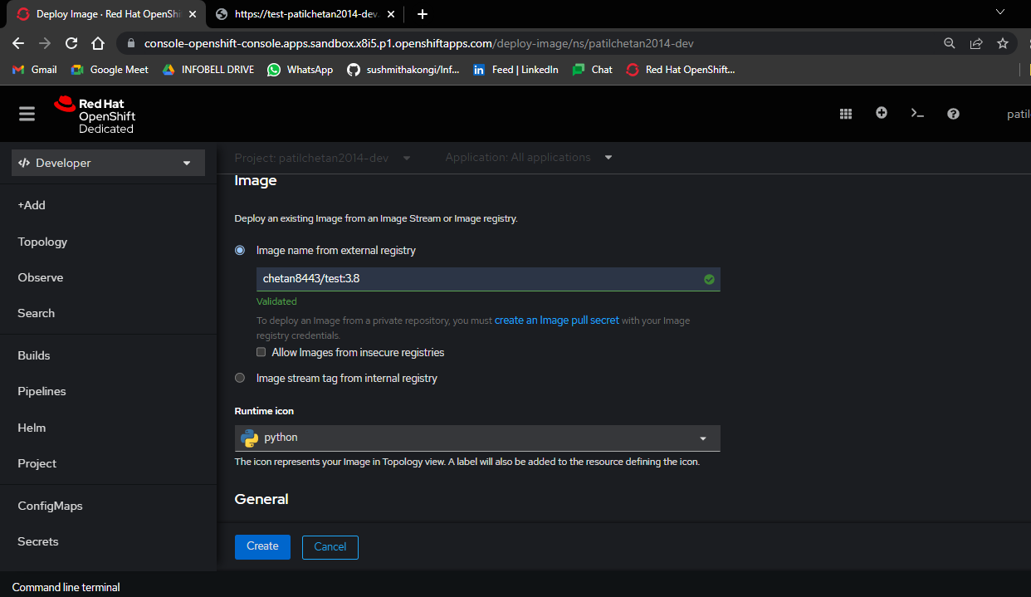

OPENSHIFT SANDBOX

PODS SCALING

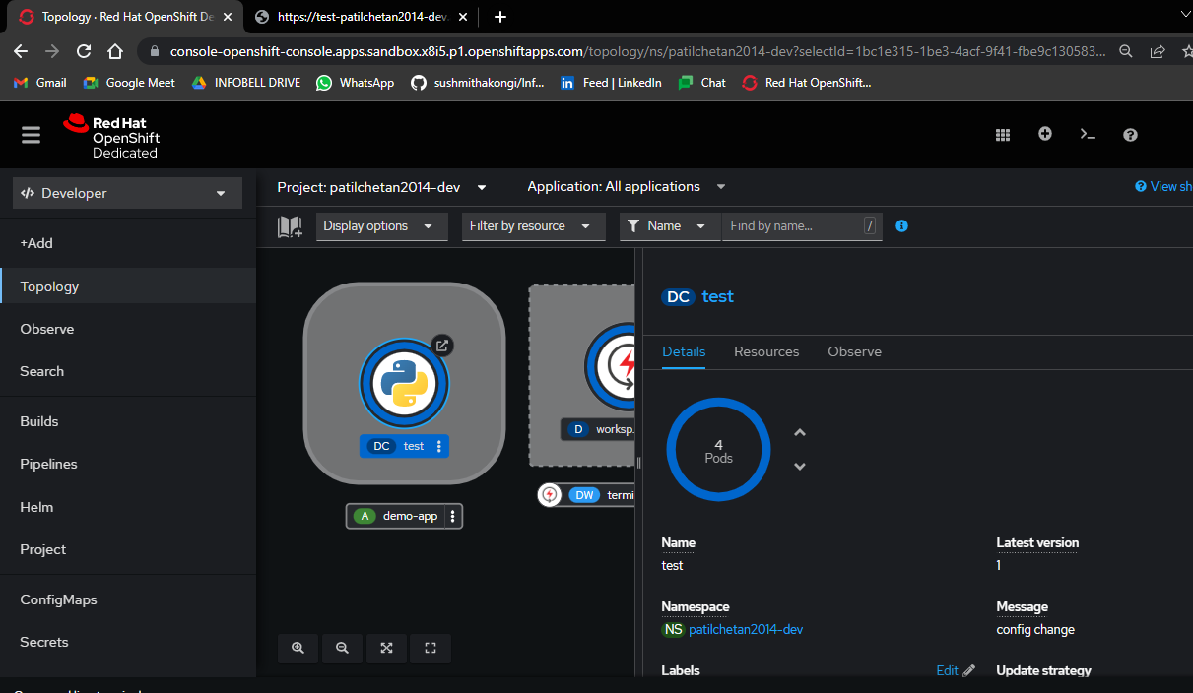

PODS

OUTPUT

